Project Report: To-Do List Application

1. Project Title
To-Do List Using Node.js, Express, and MySQL

2. Objective
The main objective of this project is to develop a visually appealing and fully functional To-Do List web application that allows users to:
- Add, edit, and delete daily tasks.
- Store all tasks in a MySQL database.
- View and manage tasks dynamically from the web interface.
The project combines backend database operations with a stylish, pink, Barbie-inspired frontend theme.

3. Tools and Technologies
- Frontend: HTML, CSS, JavaScript
- Backend: Node.js with Express.js framework
- Database: MySQL (using mysql2 npm package)
- Server Environment: Localhost (XAMPP or MySQL Workbench)
- Editor: Visual Studio Code

4. Project Description
The application is a task management tool designed with a glittery pink Barbie theme. It allows users to perform CRUD (Create, Read, Update, Delete) operations on tasks.
The app connects to a MySQL database where all tasks are stored and retrieved dynamically through API routes.

5. Database Design
Database Name: todo_app
Table Name: tasks
Column Name | Data Type | Constraints
id | INT | PRIMARY KEY, AUTO_INCREMENT
name | VARCHAR(255) | NOT NULL
SQL Command to Create Table:
CREATE DATABASE todo_app;
USE todo_app;

CREATE TABLE tasks (
id INT AUTO_INCREMENT PRIMARY KEY,
name VARCHAR(255) NOT NULL
);

6. Folder Structure
todo-app/
│
├── server.js
├── index.html
├── style.css
└── package.json

7. Installation Steps
- Initialize Project
- npm init -y
- Install Required Dependencies
- npm install express body-parser mysql2
- Start MySQL Server
Open MySQL Workbench or XAMPP and ensure MySQL service is running.
- Create Database and Table
Run the SQL commands provided above.
- Run the Application
- node server.js
- Open the App
Visit: http://localhost:3000

Output Screenshots
- Homepage of To-Do List:
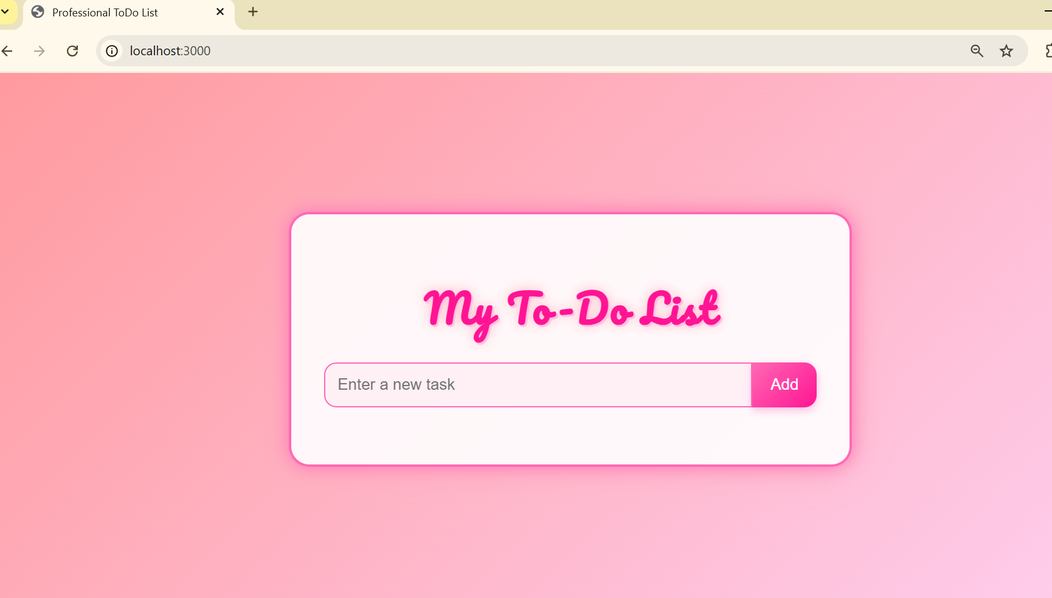

- Adding a new task: 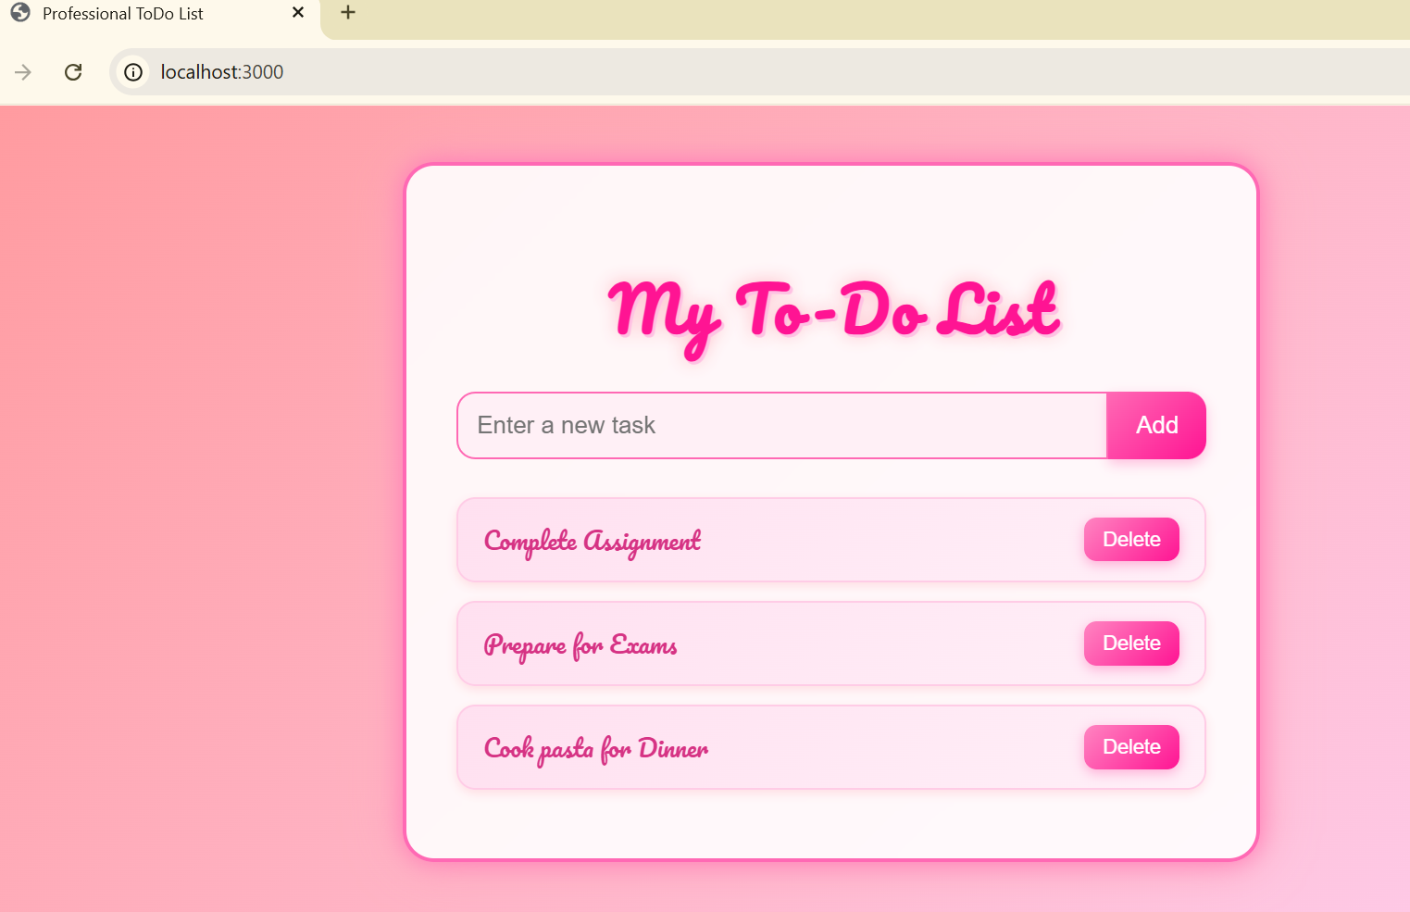

- Editing a task:
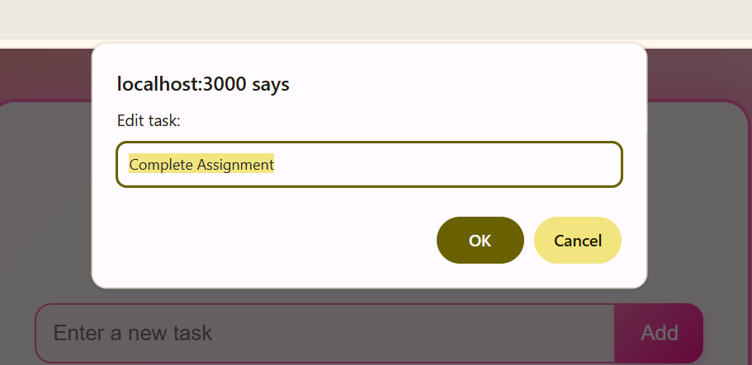
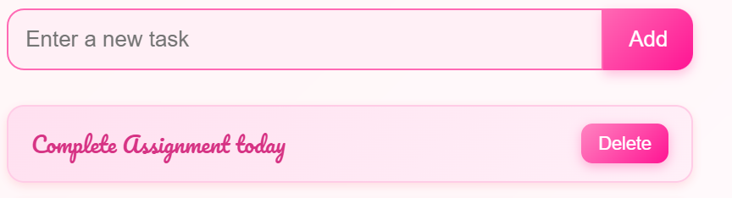
- Task deleted:
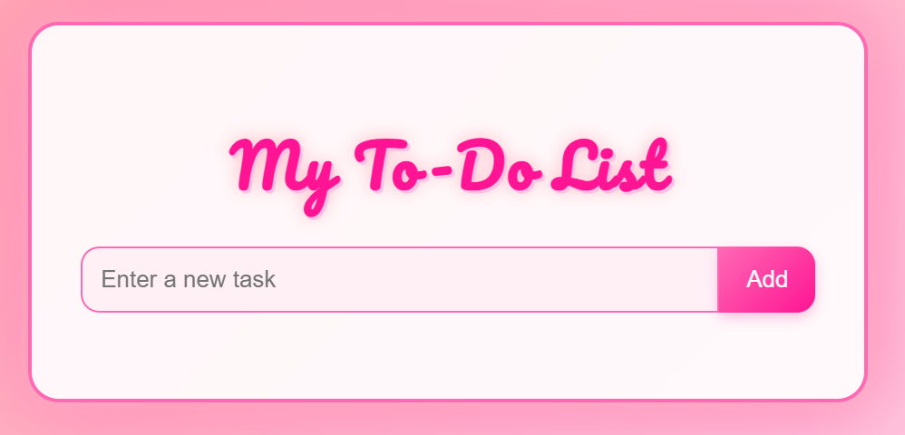
- MySQL table view:
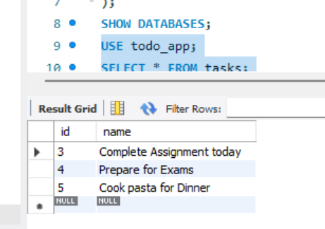

Future Enhancements
In the future, this To-Do List application can be enhanced with additional features to improve usability and functionality. User authentication can be implemented so each user has their own private task list. Tasks can include extra details such as due dates, priority levels, and completion status. A search and filter system could make task management more efficient. Integration with cloud databases or APIs would allow synchronization across multiple devices. Additionally, the interface could include animations, notifications, and progress tracking to make the user experience more interactive and engaging.

Conclusion
This project demonstrates how to integrate Node.js, Express, and MySQL to build a functional and beautiful web application.
The Barbie-inspired pink design makes it visually engaging, while the backend CRUD operations ensure full interactivity and data persistence.

